

School: .....................................................……………………..…Campus: ............…………………………………………….

Academic Year: ...................... Subject Name: .........…………………………...………. Subject Code: ……..........…….

Semester: ............... Program: ............… Branch: ..............… Specialization: ......……………………………………….

Date: .................................….
Applied and Action Learning
(Learning by Doing and Discovery)

Name of the Experiment: Cross the Chain – Bridge or Interoperability Demo
*Coding Phase: Pseudo Code / Flow Chart / Algorithm
- Start the experiment in Remix IDE.
- Create two contracts:
- LockContract → simulates the source blockchain where tokens are locked.
- ReleaseContract → simulates the destination where tokens are released.
- Compile both contracts using Solidity compiler version 0.8.x.
- Connect MetaMask to Ethereum Sepolia Testnet and ensure test ETH balance.
- In Remix, select Injected Provider – MetaMask as the environment.
- Deploy both contracts on Sepolia network.
- Lock tokens by sending Ether using lockTokens() from an account (User A).
- Observe the event log “TokensLocked” emitted from the contract.
- Call the releaseTokens() function in the second contract (ReleaseContract) using data from the first contract (sender, amount).
- Check balances on both contracts to verify lock and release.
- Record observations and transaction results.
- End the simulation.

* Software used:
- Remix IDE – For writing and deploying smart contracts.
- MetaMask Wallet – To manage accounts and connect to the blockchain.
- Ethereum Sepolia Testnet – Used as the simulation environment.
- Solidity Compiler v0.8.x – For contract compilation.
- Injected Provider – MetaMask – For contract deployment via Remix.

Page No…………….
* As applicable according to the experiment.
Two sheets per experiment (10-20) to be used.
* Testing Phase: Compilation of Code (error detection)
NO ERROR

* Implementation Phase: Final Output (no error)
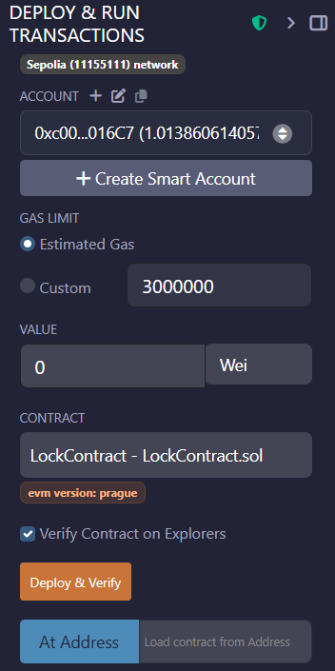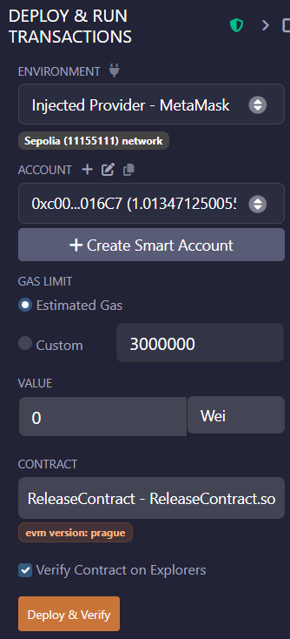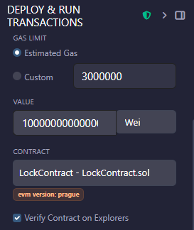
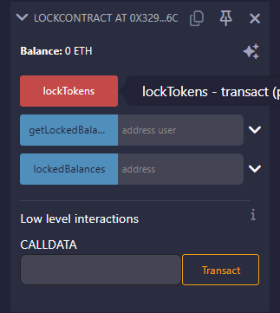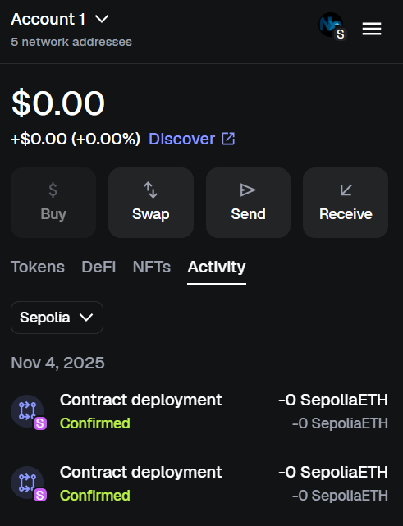
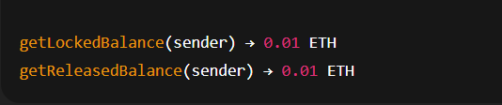

Page No…………….
* As applicable according to the experiment.
Two sheets per experiment (10-20) to be used.

* Observation :
The experiment demonstrates:
- Asset locking and event emission on one chain.
- Authorized release on another chain.
- Matching balances for locked and released assets.

ASSESSMENT

Rubrics | Full Mark | Marks Obtained | Remarks
Concept | 10
Planning and Execution/Practical Simulation/ Programming | 10
Result and Interpretation | 10
Record of Applied and Action Learning | 10
Viva | 10
Total | 50

Signature of the Student :
Name :
Signature of the Faculty : Regn. No. :
Page No…………….

* As applicable according to the experiment.
Two sheets per experiment (10-20) to be used

